SUBJECT LINE(s):
Free helpline for child care providers during the pandemic
Health and safety helpline available to child care providers
Free support on COVID-19 health and safety practices for child care

BODY:

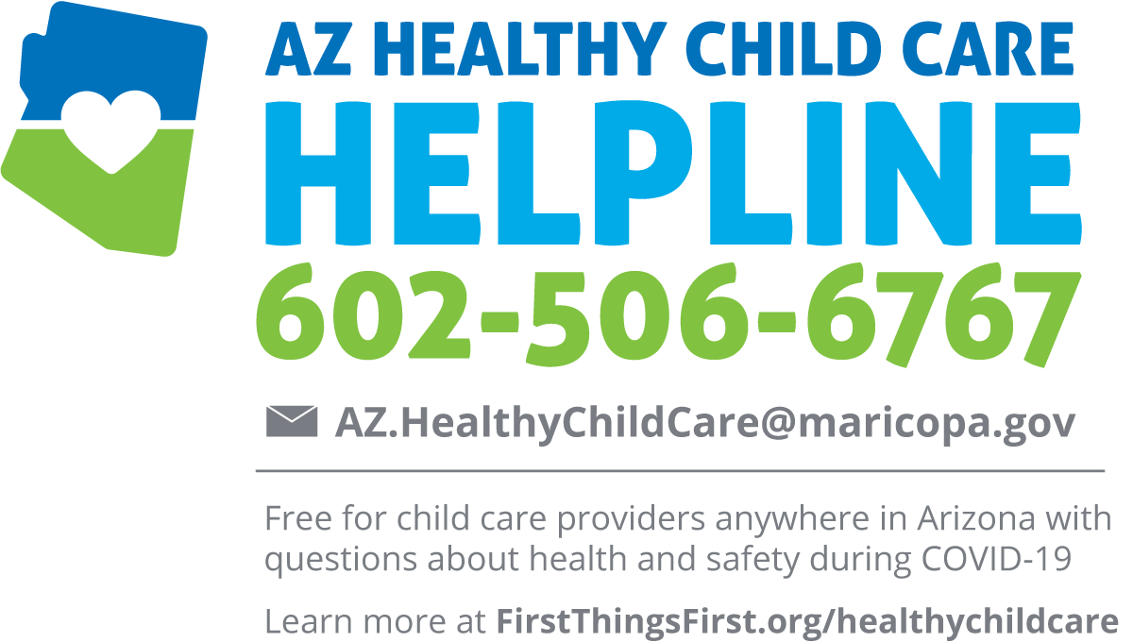

The COVID-19 crisis has been hard on child care providers in Arizona. Child care centers, home-based providers and preschools that are currently open have to deal with many health and safety issues. And those who are looking to reopen have many questions about how to do so safely.

The AZ Healthy Child Care Helpline is a free service now available to early care and education providers anywhere in Arizona to get answers to questions and expert advice on health and safety during COVID-19:

- What to do if a child or staff member tests positive for COVID-19
- What to do if a child or staff member is showing signs and symptoms of illness
- How to safely conduct daily health checks
- Setting up classroom space to support physical distancing.
- Proper use of cloth face coverings and PPE in child care

Calls and emails will be answered by child care health professionals specially trained to work with early care and education providers to help promote safe and healthy learning environments for young children and staff.

Contact the AZ Healthy Child Care Helpline at 602.506.6767, EXT 2 or AZ.healthychildcare@maricopa.gov. Hours of operation are 8:30 a.m. to 4:30 p.m., Monday through Friday.

Learn more at FirstThingsFirst.org/healthychildcare.

Note: The AZ Healthy Child Care Helpline is free and available to providers who are not already eligible to receive services from Quality First child care health consultants (CCHCs). Quality First participants can learn more about accessing CCHC services here.

